Microservices
The Microservice architecture-based approach for building applications helps solve these real-time issues and provides more space for agile development methods and faster application response.
Agile development methods are a way of building software step-by-step, with frequent feedback, quick changes, and continuous improvement, instead of finishing everything at the end.
Agile is about delivering small, working features continuously, with feedback and improvement in every sprint.
Simple Definition (Easy to Remember)
Agile = Build → Test → Get feedback → Improve → Repeat
Instead of working for months and delivering once, Agile delivers small usable parts frequently.
Why Agile is Used
Traditional method (Waterfall):
- Plan everything at the start
- Changes are difficult
- Feedback comes very late
Agile:
- Accepts change
- Delivers working software quickly
- Customer is involved continuously
Common Agile Development Methods (Types)
  - Scrum (MOST popular) – Work is divided into sprints, each sprint delivers a working feature
Roles:
- Product Owner – decides what to build
- Scrum Master – removes blockers
- Development Team – builds the product
  - Kanban
  - Extreme Programming

Agile Methodology – How It Is Executed (Developer View)
Employee CRUD Module
(Create, Read, Update, Delete Employee)
  - Product Backlog (Before Development Starts)
What happens:
- Product Owner (PO) collects requirements
- Requirements are written as User Stories
Example User Stories (CRUD)
- US-1: As an Admin, I want to add an employee so that new employees can be onboarded.
- US-2: As an Admin, I want to view employee list so that I can manage employees.
- US-3: As an Admin, I want to update employee details.
- US-4: As an Admin, I want to delete an employee.
👉 As a developer, you must understand user stories clearly
(not technical yet).
  - Sprint Planning (Start of Sprint – Day 1)
What happens:
- Sprint duration decided (usually 2 weeks)
- Team selects stories from backlog
- Stories are broken into tasks
Example Sprint Scope:
Sprint 1 → Employee CRUD (basic)
Task Breakdown (Developer View)
US-1: Create Employee
- Design Employee table
- Create DTOs
- Create API (POST)
- Validation
- Unit testing
US-2: Get Employee
- GET API
- Pagination
- Testing
  - Sprint Backlog (Your Daily Work)
- What you see as a developer:
- Tasks assigned to you in Jira / Azure DevOps:
Task | Status
Create Employee API | To Do
Employee DTO | In Progress
DB migration | Done
- 👉 You pick tasks, not full features.

  - Daily Stand-up (Every Day – 15 minutes)
You answer only 3 things:
- What did I do yesterday?
- What will I do today?
- Any blockers?
Example:
Yesterday I completed Create Employee API
Today I will work on Get Employee API
No blockers
🚫 No technical discussion here.
- Development (Actual Coding – CRUD)
- Testing (During Sprint, Not at End)
• QA tests CRUD APIs
• Bugs are logged
• Bugs become new tasks

- Sprint Review (End of Sprint)
What happens:
- Team demonstrates working CRUD
- Product Owner gives feedback
Example:
PO says:
We need search by employee name also
👉 That becomes a new user story for next sprint
(No sudden changes in current sprint).
- Sprint Retrospective (Internal Team)
Team discusses:
- What went well?
- What went wrong?
- How to improve?
- • API reviews helped reduce bugs
- • Need better estimation next sprint
- Increment Delivery
- What YOU Must Know as a Developer (IMPORTANT)
- You must be comfortable with:
- ✅ User Stories
✅ Task breakdown
✅ Working in sprints
✅ Daily stand-ups
✅ Incremental delivery
✅ Handling changes calmly
Boilerplate code : Boilerplate code = Repetitive, standard code that is required but not unique to your business logic
It’s the code you must write every time, but it’s mostly the same.

Refactoring : Improving the internal structure of code WITHOUT changing its behavior, The output stays the same — only the code quality improves.
Prototyping: Quickly building a simple version of a feature to understand or validate an idea is not final production code. Eg: Simple API without full validation

Plugins: Plugins are add-ons that extend the functionality of tools or platforms
They don’t work alone — they enhance something else.

What are Microservices?
  - It is an architectural approach to building applications from small to large scale applications.
  - With this approach , application is broken down into the smallest components, independent of each other.
  - In monolithic architecture, all the functionalities are targeted to build into a single project/Application
  - Microservices separate functionalities to develop in a more modular way,
  - All the modules work together to accomplish targeted tasks.
  - Developing applications using this architecture pattern gives software more flexibility,modularity (designing by breaking into smaller,independent parts) instead of one big block , lightweight (starts fast, use less memory, has minimum configuration,avoids unnecessary features)
  - Microservices applications are maintained in different servers , so maintaining it efficiently without downtime is very necessary.
  - provides the ability to develop multiple Microservices simultaneously
  - This means more developers working on the same app but different functional modules simultaneously which results in less deliverable time of application to the client.
Advantages of using Microservice
  - Faster Development : applications developed in smaller modules, development time is shortened, micro architecture supports agile development process, multiple team work on each module
  - High Scalability : As user demand for some services in the application grows, you can deploy those services across multiple servers and infrastructures to meet your needs. As much as the usage of services increases by end-users, the deployment and extension of Microservice can be handled by load balancing.
  - Resilient & Independency: The independent services, after properly developed and orchestrated, do not impact one another. This means that if one service fails to work, the whole app won’t go down, unlike the monolithic application model.
  - Easy of Deployment : Application deployments and application downtime are reduced.
  - Accessibility for Development : Since the larger app is broken down into smaller modules, developers can easily understand, update, and enhance the new changes, which results in fast development cycles if planned with agile development methodologies

Microservice Vs. Monolith Architecture

Feature / Aspect | Monolithic Architecture | Microservices Architecture | Example (HRMS/Payroll)
Development Style | Dependent & compounded development of UI, business logic, and database logic | Multiple services developed with a single purpose each | Payroll, Employee, Attendance developed as separate services vs all in one solution
Database | Single database shared by all modules | Dedicated database per microservice | One DB for Employees, Payroll, Attendance vs separate DBs for each service
Technology / Language | Single programming language for the backend | Each microservice can use different technologies | Entire HRMS backend in ASP.NET vs Payroll in ASP.NET, Reporting in Python
Deployment | Single solution deployed as one unit; scaling or updating is complex | Each microservice can be deployed independently anywhere | Updating Leave module requires redeploying entire HRMS vs deploying only Leave service
Coupling | Modules are tightly coupled; changes in one can affect others | Loosely coupled; services interact via APIs or events | Payroll bug may crash entire app vs only Payroll service affected
Scalability | Hard to scale individual modules; entire app scales together | Can scale each service independently | Payroll processing load requires scaling whole app vs only Payroll service
Maintenance | Harder to maintain as code grows; risk of breaking other modules | Easier to maintain; services are isolated | Changing database schema affects entire app vs affects only the relevant service
Example Use Case | Small HRMS project or MVP | Large-scale enterprise HRMS | Small startup HRMS vs multi-team enterprise HRMS with microservices for Employee, Payroll, Attendance

In monolithic architecture, if we deploy an application to a single server , then updating the application and pushing requires re-deployment of the same application to the server , the whole application has to move to downtime and go through several unit tests to ensure that the new enhancement did not break existing functionalities.
But if you had followed a Microservice Architecture, you would have made Separate Components for Student Admission, Student Attendance, etc. That means you have 2 different API Projects specific to what a Student Admission Endpoint and a Student Attendance Endpoint needs. Now, these different APIs (Microservices) can be deployed anywhere in the Web world and don’t need to get deployed along with the Main Application. You can create a clean separation and physically decouple the Application into various parts.
Example of a Student management application
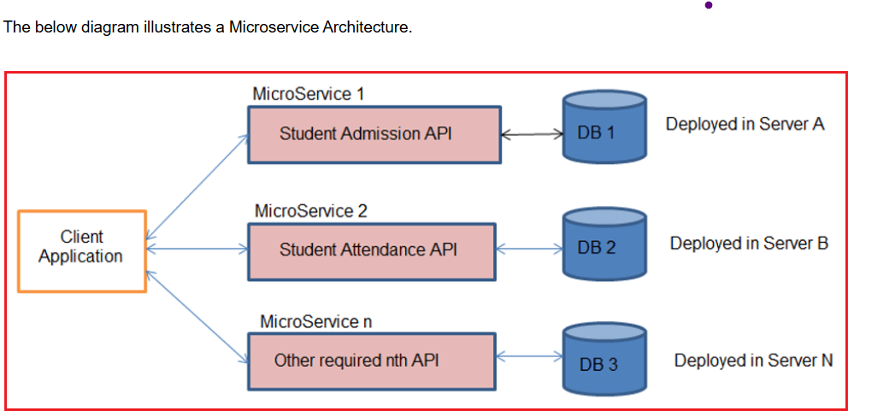

Understanding API Gateway (Ocelot Gateway with example)
API Gateway is a middleware layer that directs incoming HTTP request calls from Client applications to specific Microservice without directly exposing the Microservice details to the Client and returning the responses generated from the respective Microservice.

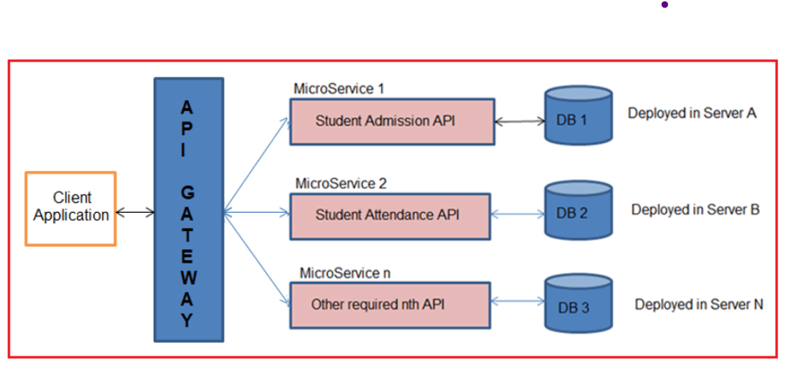
  - Ocelot is an Open-Source API Gateway for the .NET/Core Platform officially supported by Microsoft
  - It mimics masking multiple microservices existing so that the client does not have to worry about the location of each and every Microservice.

Features of API Gateway
  - API virtualization: API Gateways act as a single point entry for all the microservices configured, avoid direct availability of microservices to clients, and hide versioning details of microservices.
  - Serves as an additional layer of security microservices: API gateways prevent malicious attacks by providing an additional layer of protection from attack vectors and hackers like SQL Injection, XML Parser exploits, denial-of-service (DoS) attacks, and forged form data submissions.
  - Decreased microservice complexity : Authorization techniques such as JWT and other development concerns can constitute more time for the development of each microservice. An API gateway can handle these concerns independently and remove the development burden from your API code.
  - If there are 50 or above microservices created for one main application, the client(Angular or React requests to the server) may get confused to know about each one of them
  - So to overcome that , we introduce a concept called API gateway- this is placed right in between the clients and the microservices.
  - This gateway re-routes all the api endpoints and unifies it under a single domain so that the client no longer cares about the 50 microservices.
- localhost:11223 will be re-routed to localhost:40001/api/product/
localhost:22113 will be re-routed to localhost:40001/api/customer/
- Where localhost:40001 is the location of your API Gateway. In this way, your client connects to the gateway, which in turn re-routes the data / endpoints to / from the Microservices. This is quite enough for now. We will go into more detail later in this article, once we get started with the development. I hope that the Diagram makes quite a lot of sense now

Example scenario: As mentioned earlier, here is the requirement. We will have to build a simple Microservice Architecture in ASP.NET Core with API Gateways. For starters, let’s have 2 Microservice WebAPIs that perform CRUD Operations for Customers and Products. We will also need an API Gateway that is responsible for re-directing the incoming request from the client (Here, a browser or Postman would be the client) to and from the Microservices. To be more clear, the client has to access the API Gateways and perform the operation over the Microservices.

Basically, all the CRUD Operations related to the Customer go to the Customer.Microservice and everything related to the Products goes to the Product.Microservice. The Client will be accessing the gateway’s URL to use the Customer and Product Operations. Ideally, the Microservices will be something internal and will not be accessible by the public without the help of the API Gateway.

Introduction to Ocelot API Gateway
Client → API Gateway → Microservices
Without Gateway → client must call 5–10 services directly (bad design)

  - Ocelot is an Open Source API Gateway for the .NET/Core Platform
  - It unifies multiple microservices so that the client does not have to worry about the location of each and every Microservice.
  - Ocelot API Gateway transforms the Incoming HTTP Request from the client and forwards it to an appropriate Microservice.
  - Ocelot is widely used by Microsft and other tech giants as well for Microservice Management.
  - setting up a JSON Configuration file that states the upstream and downstream routes.
  - Upstream and Downstream are 2 terms that you have to be clear with
  - Upstream: An upstream Request is the Request sent by the Client to the API Gateway.
  - Downstream : It is the request sent to the Microservice by the API Gateway

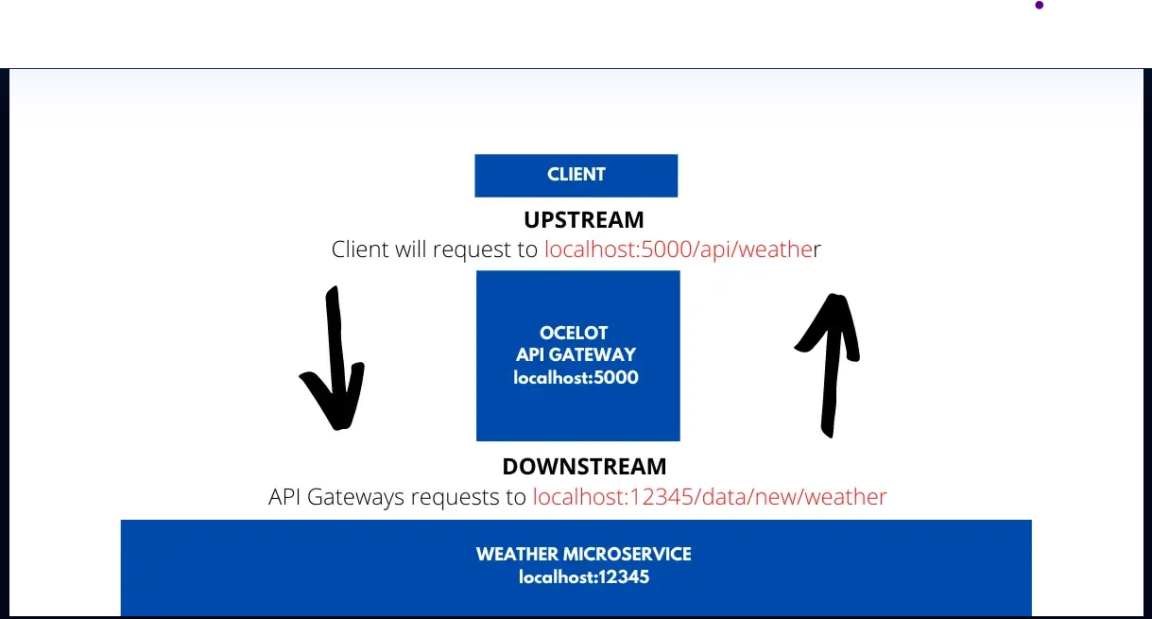

Explanation of the above screenshot: it shows how the client and server communication is happening with the help of the API Gateway.
  - The API gateway is located at port 5000
  - the Microservice Port is at 12345
  - Now, the client will not have access to port 12345, but only to 5000
  - Thus, the client sends a request to localhost:5000/api/weather to receive the latest weather
  - Now the ocelot takes in the incoming request from the client and sends another HTTP Request to the Microservice, which in turn returns the required response
  - Once that is done, the Gateway sends the response to the client
  - Here is localhost:5000 is the upstream path that the client knows of. localhost:123456 is the downstream path that the API Gateways knows about
- In this way, Ocelot API Gateway will be able to re-route various requests from clients to all the involved Microservices. We will have to configure all these routes within the API Gateway so that Ocelot knows how and where to route the incoming requests.
Features of Ocelot
  - Routing the incoming request to the required microservice
  - Authentication
  - Authorization
  - Load Balance for Enterprise Application.

